Section 6.1: Early Greek Civilization
Vocabulary
Peninsula

Acropolis

Aristocrat

Tyrant

Democracy:

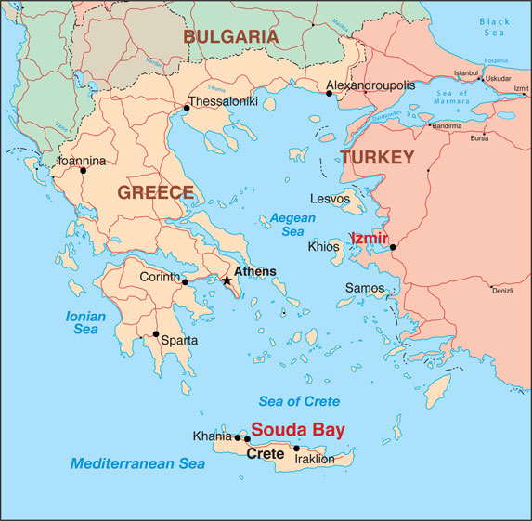
The Geography of Greece
The land of Greece looks as if the ____ had _______ it into pieces. Greece is a ____________ made up of smaller peninsulas and ___________.

The Mountains of Greece
Mountains are the major ____________ of Greece. Greek islands are mostly _________ ___________. Only about one ________ of the land is good for ____________ __________. Due to this fact, many Greeks became ___________ and _________.

Geography and Ancient Communities
Ancient Greeks were all _____________. Some were surrounded by _________, but others were surrounded by _____________. This was known as a __________ island.

Because it was ____________ for Greek communities to ________, they each developed their own ___________ and _________. Greek communities were so busy __________ one another, they seemed to forget that they shared a __________ ____________, _______________, and ____________.

The Rise of Greek Civilization
Two ancient people. the __________ and the ___________ made important contributions to Greek civilization.

Minoan Civilization
From _______ to __________, Minoans lived on the island of _________. Surrounded by the __________ and _______________ seas, they developed __________________________. Lands that traded with the Minoans include _________, ___________, and _________.

Minoans developed an ____________ culture. Samples of writing were found on thousands of _____________. Palace ruins in the city of __________ show detailed wall paintings. Statues found suggest that they worshipped ______________________. In the mid _________, the city was ________ and the civilization ____________. Likely invaders included people from _________ and ___________.

The Mycenaeans
Once the_____________ came to power, island and mainland _________ blended. Around _______ B.C., they controlled _____________ and_______________. Studies have shown that the Mycenaeans spoke an early form of ____________. These people gained most of their power through _________. Greek myths tell the story of the ____________, which was a real struggle between _________ and __________. Troy is located on the __________ of _______________, in present day ___________. The real struggle was over ________ and _______, although the ________ was invented.

The Trojan War
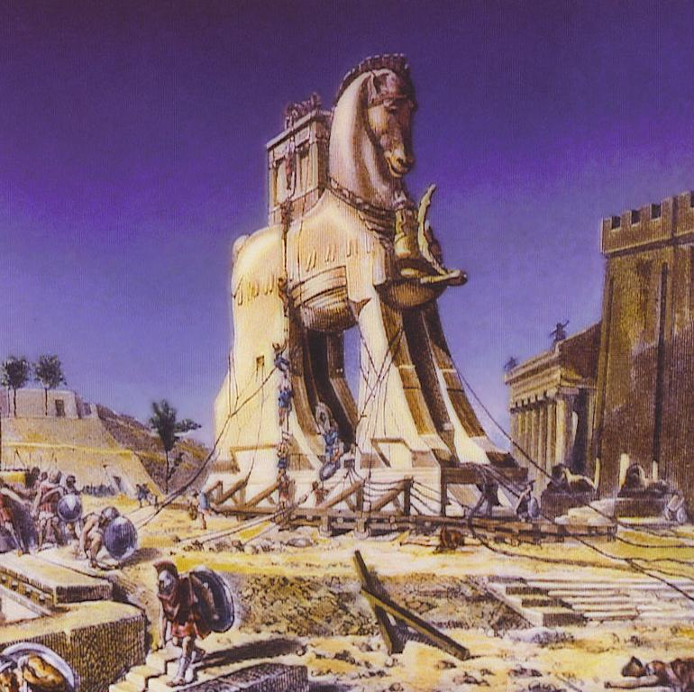
According to _________, Greece conquered troy using a ________________.

Describe the events of the trojan war below.

Two ________, or long storytelling _______, about the war still exist. Both said to be written by the poet _________, they are called __________ and ____________.

Why were these poems important to the Greek people?

The Dark Ages of Greece
Shortly after the Trojan War, Greece ___________. ___________ was everywhere, and nobody _______ with Greece beyond food. They had to depend on what they could _______ or ________ themselves.They were so worried about ________ that they even forgot the art of ___________.

The years between ________ and _________ were known as ________________. People had to depend on __________ to keep their ________ and __________ alive. During this time, families were able to_______ in areas where they could grow crops. Some of these farms developed into ____________. They favored places near ________ where they built ____________ to protect themselves from attack. This type of settlement in Ancient Greece is know as __________.

Governing Ancient Greece
Villages began joining together around _______ to form _________. As cities developed they became _____________.

The Rule of Aristocrats
The earliest rulers of city states were likely _________ or _________ who were military leaders. By the end of the Dark Ages, they were ruled by _____________. These people were stronger than others because they owned _________, ____________, and ____________.

A New Type of Ruler
As Greek trade improved, city states became __________. A middle class developed including ___________ and __________. They wanted a say in ___________, but could not afford major weapons for war. They could afford _______, __________, and ___________, which allowed them to fight on ______. Military power shifted away from the ___________.

As a result, aristocratic rule was often _______ and replaced with rulers called __________, who were _________ by the _________ and ___________classes.
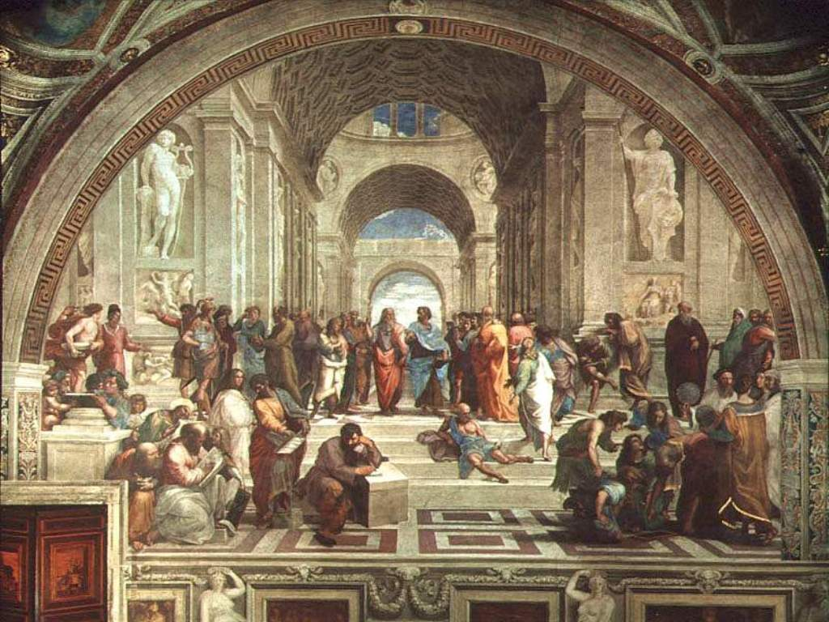
Democracy: Rule by the People
People of the city-states eventually overthrew tyrants that were too _________. They replaced this rule with a form of self-government known as __________. The city where democracy was most developed was ____________.

In ________ the leader _________ reformed Athen’s laws.Two laws that he changed included:

Citizens in Athens could be _______ or _______, but only about one in ______ Athenians was a citizen. Only ______ could be citizens. But these men had to have two_____ who came from __________ with citizenship.

People who could not be slaves included:

