Artisans, Buildings, and Craftsmanship in the Bronze Age

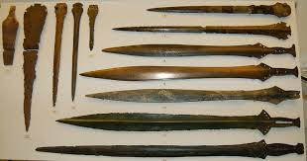
Directions: Each of you will be given a small amount of tin foil to manipulate into something that represents the Bronze Age (bronze was made from copper and tin). Use the suggestions listed below, or research your own idea. Remember that the Bronze Age is time of craftsmanship and skill. People no longer had to worry as much about food sources so they could put their energies into building shelters, tools, supplies, or works of art. On the back of this paper, write a short statement that explains your craft.

Project Options:

- Tools: For farming, hunting, or building.
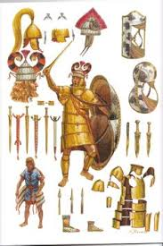
- Armor and Clothing: For ceremonial or military reasons.

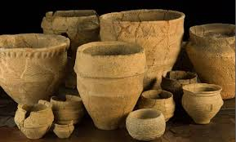
- Pottery: to store food, grains, supplies.

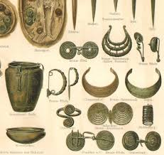

4. Jewelry: for decorative purpose, or to demonstrate wealth.

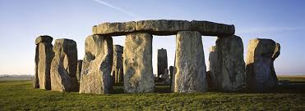
5. Shelter/Structures: a reflection of the farming and settled lifestyle. Permanent structures were built.

6. Other?

Artist Statement: Answer some of the following questions in COMPLETE sentences. What does your craft represent? How is it connected to the Bronze Age? Why was it important to the Bronze Age? What does it show about life during this time. How easy/hard was it for you to create? Are you satisfied with your final product?

