Chapter 2.2 Notes: The Fertile Empires

Vocabulary
Empire:
Babylon:
Caravan:
Bazaar:
Zoroastrianism:

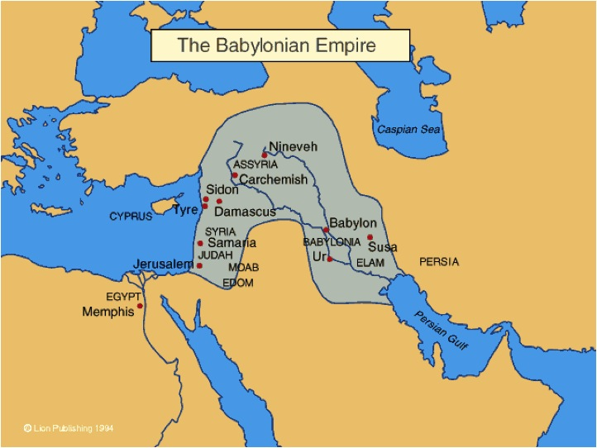
The Babylonian Empire
___________ was a ruler who created the ______________ Empire in ________.

The center of the empire was the city of ______________.

The Babylonians built ________. These roads made ________ easier and encouraged __________.

What are two examples of items purchased at the Babylonian markets?

Although rich, Hammurabi’s empire was conquered by ____________.

The Empire of the Assyrians
Why did the Assyrians become skilled warriors?

The Assyrian’s major contributions to the art of war include:

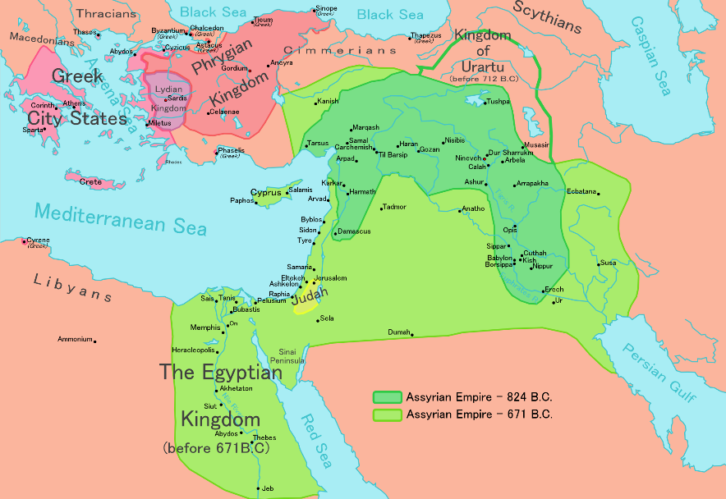
The capital of Assyria was:

The capital became a city of _________________. It included a _________ with many _________ from _________ and Babylon

Why and how did the Assyrian Empire fall?

Babylonia Rises Again
Under the _____________, Babylon rose again. The Empire controlled _________________________.
The ruler of the new empire was:

How did her protect the city?

He also built ____________________ decorated with ______________________.

In the space below, describe the royal palace.

Babylon became the center of ______________ and _________________.

How did the Chaldeans use their knowledge of Mathematics?

Chaldeans were also farmers of:

In _______________, this empire was conquered by ______________ led by _____________________.

The Persian Empire
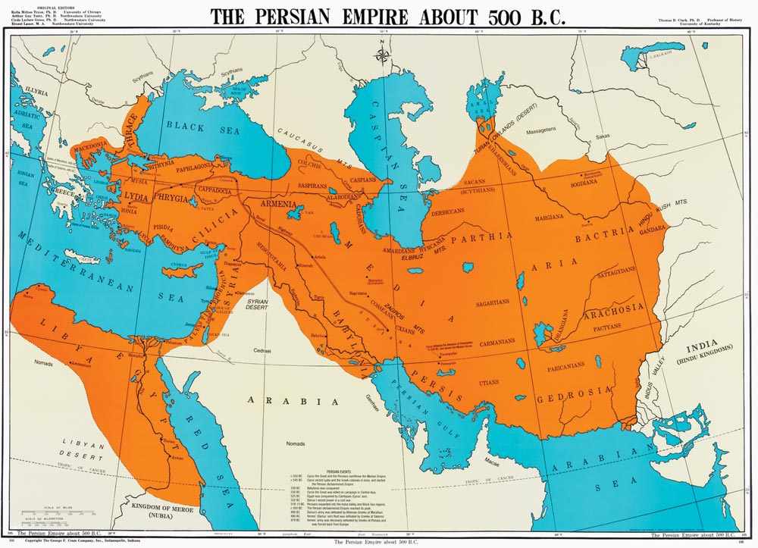
The Persians built the _________ Empire of the Fertile Crescent.
By ___________ the empire stretched from ____________ to _____________.

What religion did Persians practice?

How was this religion different from other religions in this area?

To rule the empire, Persia developed a _______________. This form of government had many _____________.

What feature made trade and travel easier in this large empire?

What are two examples of how Persia tolerated other civilizations?

Through ____________ and trade, Persia was able to spread:

