Questions to ask yourself when reviewing your story ending

Reread your story ending with these questions in mind:

- Is there a clear resolution to my story? (Was the conflict resolved?)

- Does my story flow from beginning to end?

- Does the ending relate to the events of the story?

- Have I left my readers with something to think about?

Remember: Just as an essay needs a conclusion…so do narratives!

Going Out With a Bang: Effective Endings

Story endings should help readers understand how the characters are different than they were at the beginning of the story because of the experiences that they have had. They tie up loose ends and give the reader something to think about in the future.
Ending | Description | Sentence Starter / Example
Reflection | Thinking back on the events of the story | I will never forget…because…  Now I know…
Moral | Uncover a lesson learned | The greatest thing I learned from today is…
Advice | Give advice to the reader | Be careful when…  Just remember…
Question | Reflect on a final question | Who could have known…?
Sequel | Give a glimpse of what might happen next | The next time…

Write Your Own Ending
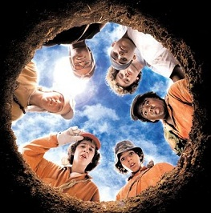
Directions: In your groups, work together to write an ending for the picture above. Each group will be assigned one ending type to focus on.

1. Reflection: ________________________________________________________________________________________________________________________________________________________________________________________________________________________________________________________________________________________________________________________________________________________________________

2. Moral: ________________________________________________________________________________________________________________________________________________________________________________________________________________________________________________________________________________________________________________________________________________________________________

3. Advice:
________________________________________________________________________________________________________________________________________________________________________________________________________________________________________________________________________________________________________________________________________________________________________

4. Question:
________________________________________________________________________________________________________________________________________________________________________________________________________________________________________________________________________________________________________________________________________________________________________

5. Sequel:
________________________________________________________________________________________________________________________________________________________________________________________________________________________________________________________________________________________________________________________________________________________________________

