Observations, Inferences, and Predictions
As readers, we are able to make observations, inferences, and predictions to gather information from and understanding of a text. In order to use these strategies effectively, we must recognize the differences between them.
- An OBSERVATION is what you can clearly see within a text based on what the author is telling you.
- You make an INFERENCE when you use information from the text AND what you know to figure out something about the text the author didn’t tell you.
- A PREDICTION is made when you use what you know from the text to make an educated guess about what will/could happen next.
Consider the picture below:
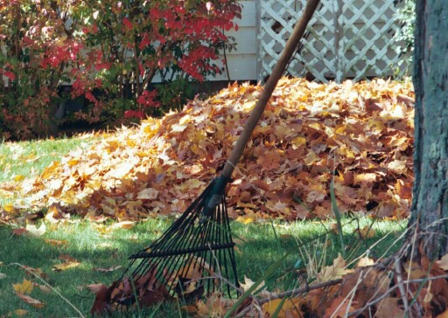

Observation: Outside of the house there is a pile of leaves and a rake leaned up against a tree.
Inference: Somebody has raked the leaves from the tree.
Prediction: The children will jump in the leaf pile.

Now you try!

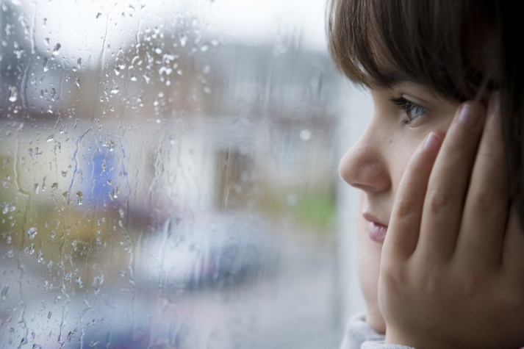
Observation:

Inference:

Prediction:

Directions: Use the graphic organizer below to record what you see, know, infer, and observe while reading The Bear Boy.
What I See | What I Know | What I Infer | What I Predict

