Sensory Details

Directions: Use the chart below to record your sensory words and phrases.
Sight  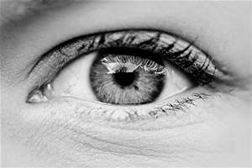 | Touch | Smell | Hear | Taste

Questions to Consider When Adding Sensory Details

Directions: Use the chart below to help you brainstorm ways to add sensory details within your own writing.
What does my character see? | Words to Describe What They See:
What can my character hear? | Words to Describe What They Hear:
What does my character touch? | Words to Describe What Touch :
What does my character taste? | Words to Describe What They Taste:
What does my character smell? | Words to Describe What They Smell:

